Servo Driver V1 Reference Document / Design Report
THIS DOCUMENT PERTAINS TO THE PREVIOUS VERSION OF THE SERVO DRIVER

By John Nguyen

29 April 2025

Summary

This is a simple circuit that allows the user to control the duty cycle of a 50Hz square wave generator with a potentiometer, between 5 and 10% duty cycle. This falls within the standard R/C PWM signal range that servos and brushless ESCs take as input.
However it is not recommended to power brushless ESCs, as there is no signal cutoff switch on the board, so reliable motor cutoff is not possible.

Circuit Design

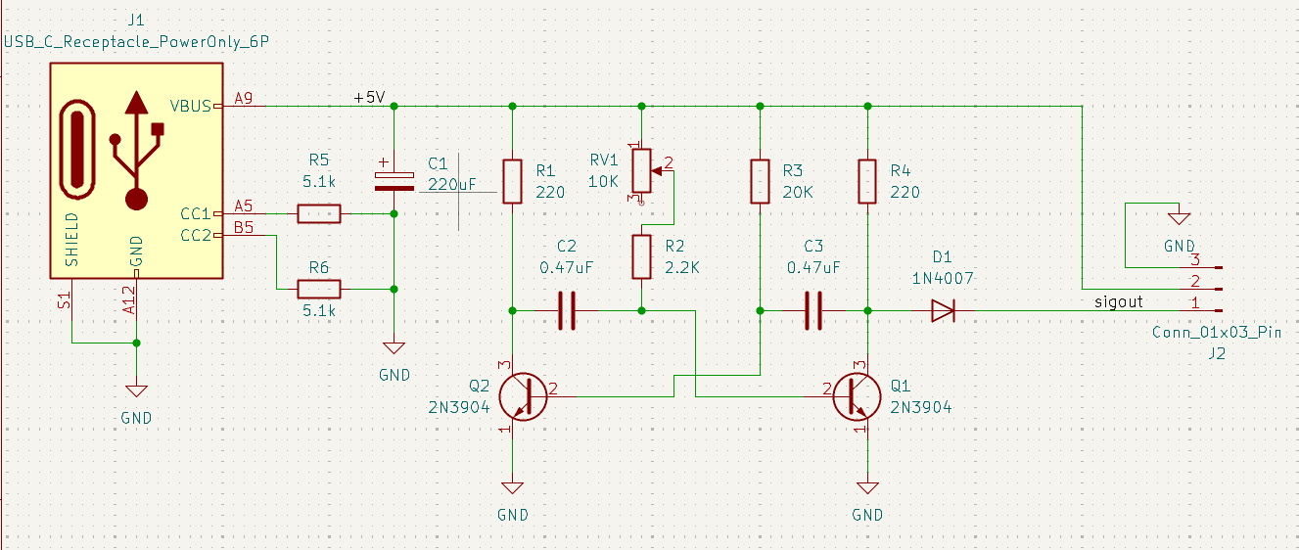
On the left we have the USB-C power delivery connector. The two 5.1k resistors tied to ground are the USB-Power Delivery pulldown resistors, which signal compatible USB devices to send power through more pins and provide up to 5A of current.

C1 is the smoothing capacitor, which takes the ripples out of poor quality power supply signals and stabilizes the oscillator. The value of this cap doesn’t really matter as long as it’s more than about 50uF.

The next section from R1 to Q1 is the astable multivibrator circuit. The network of resistors and capacitors connected to the two NPN transistors (Q1 and Q2) create a square wave generator.
The on-time of each side of the circuit is equal to R*C*pi. (though note that the output, taken from Q1 collector, actually sees the on-time of the opposite side of the circuit. When Q1 is active, its collector is pulled down to 0.7V).
As such the on-time of the static side (R3, R4, C3) is equal to R3 * C3 * pi = 29.53 ms.
The on-time range of the dynamic side (R1, RV1, R2, C2) is minimum at RV1 ~~ 0: R2*C2 * pi = 3.24 ms, and maximum at RV1 ~~10K: (RV1+R2)*C2*pi = 18.01 ms.
These are the wrong values!!! R/C servos are supposed to operate on control pulses between 1 and 2ms wide, with the neutral position at 1.5ms. However with component substitutions:
R2 → 680
RV1 → 1K
We can achieve the correct pulse width range:
Minimum 1.004ms with RV1 ~~0
Maximum 2.481ms with RV1 = 1K

Corrected circuit diagram:
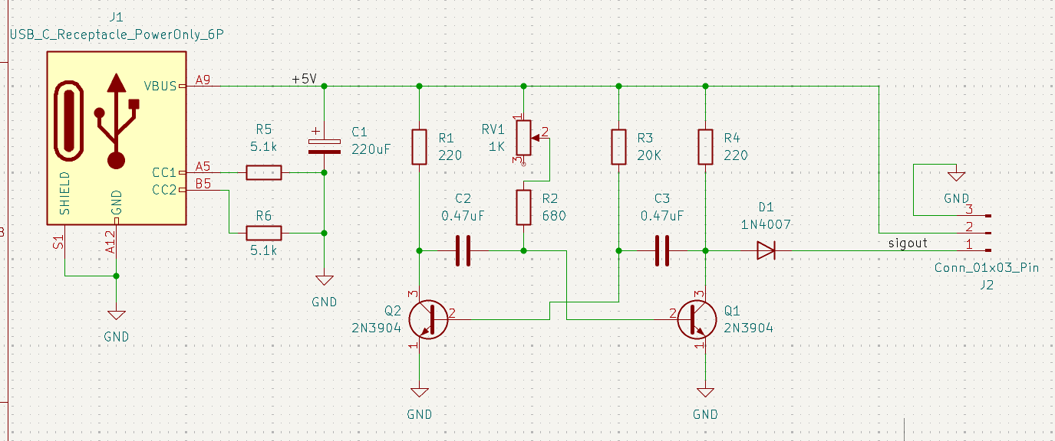
(PCB overview on next page)

Printed Circuit Board
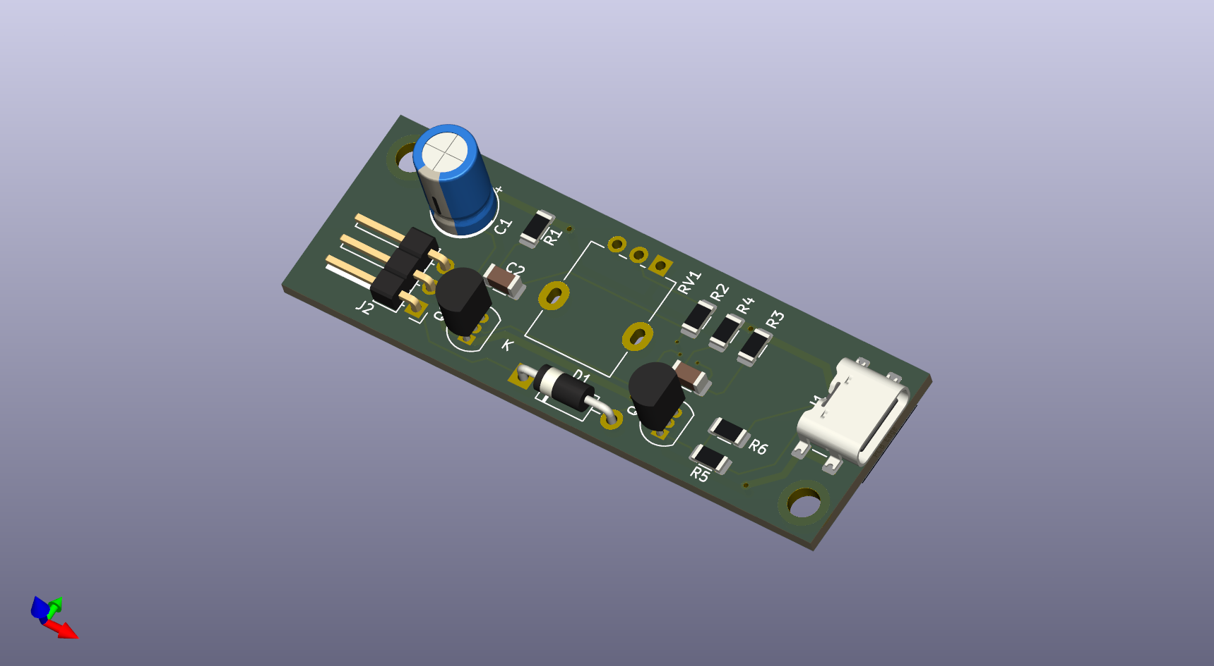
The PCB for this project was designed using KiCad 9.0 (a free and open source EDA suite). I attempted to make the board as small as possible, with the USB power input on one end and the 3-pin PWM output on the other. The PWM output is horizontal to help mounting in a 3D-printed case for eventual deployment as part of a larger system.
The board is 2.4 inches long and 0.82 inches wide. With a 20mm potentiometer mounted, the total stackup should be about 1.25 inches tall. The board is 2 layers on an FR-4 core, designed for the DigiKey Red PCB fabrication service here in America. The power traces are 0.75mm wide (30mil) which should be sufficient for the expected current draw of small servos.

